Attaching some screenshots for reference.
- Mongo DB:
  - The below screenshot shows Mongo DB Instance holds 10 documents.
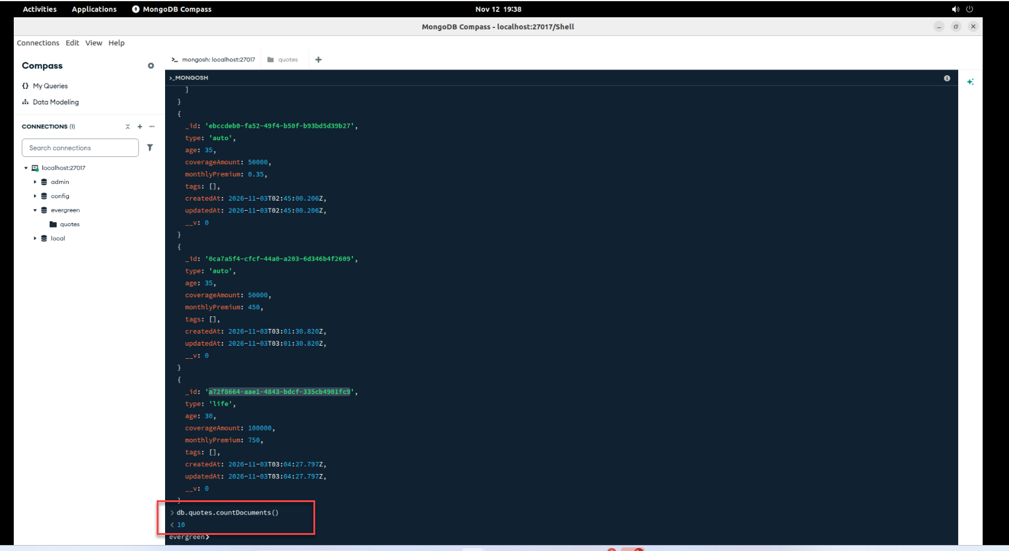

  - Used a Post command to insert a new Quote to DB. After Insertion, The document count was validated and it shows 11 which is expected.
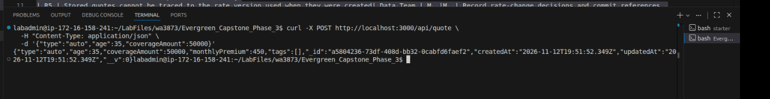
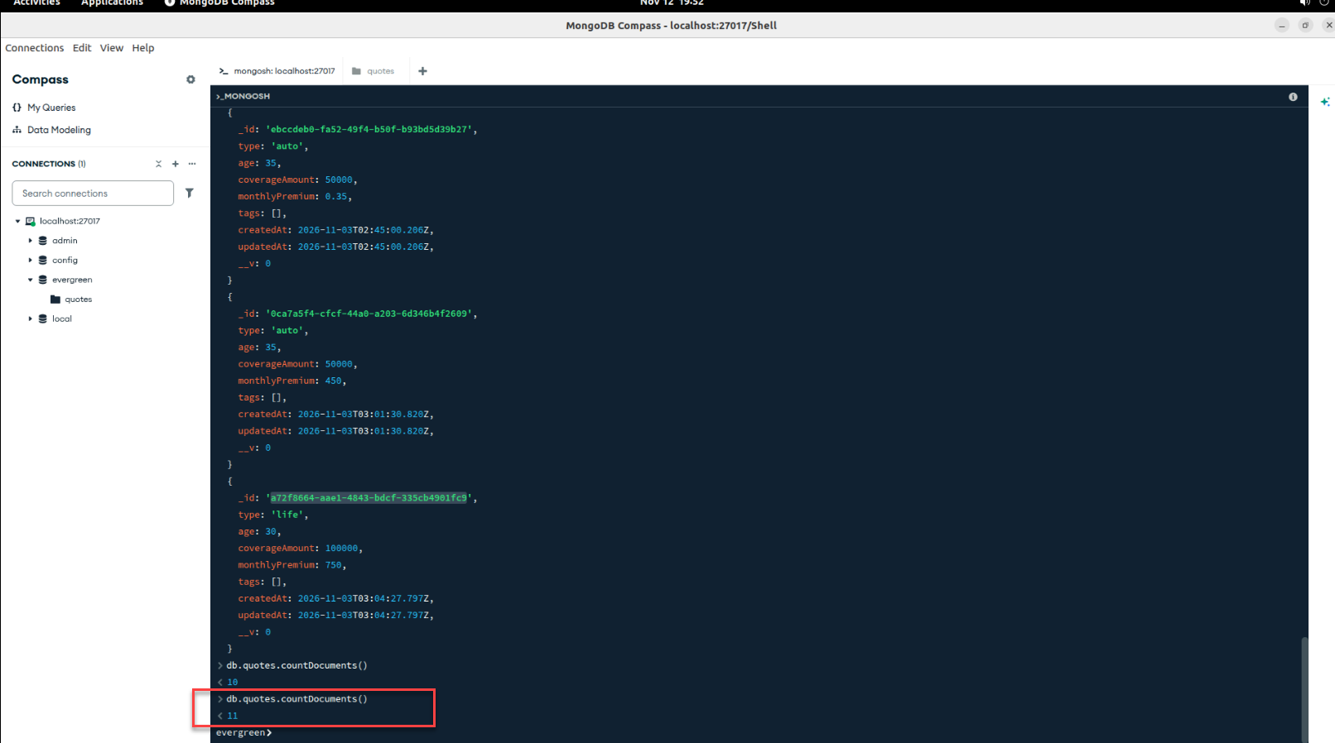

- Docker:
  - Image generation was successful.
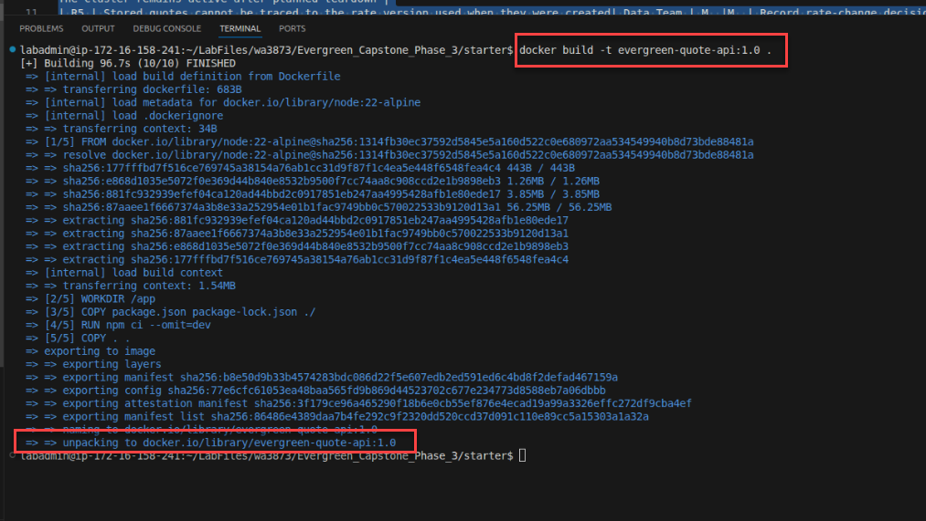
  - The Image was running in port 3000 of Local host.
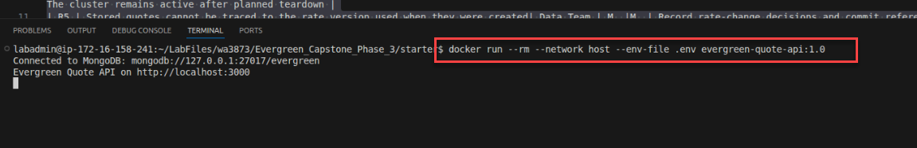
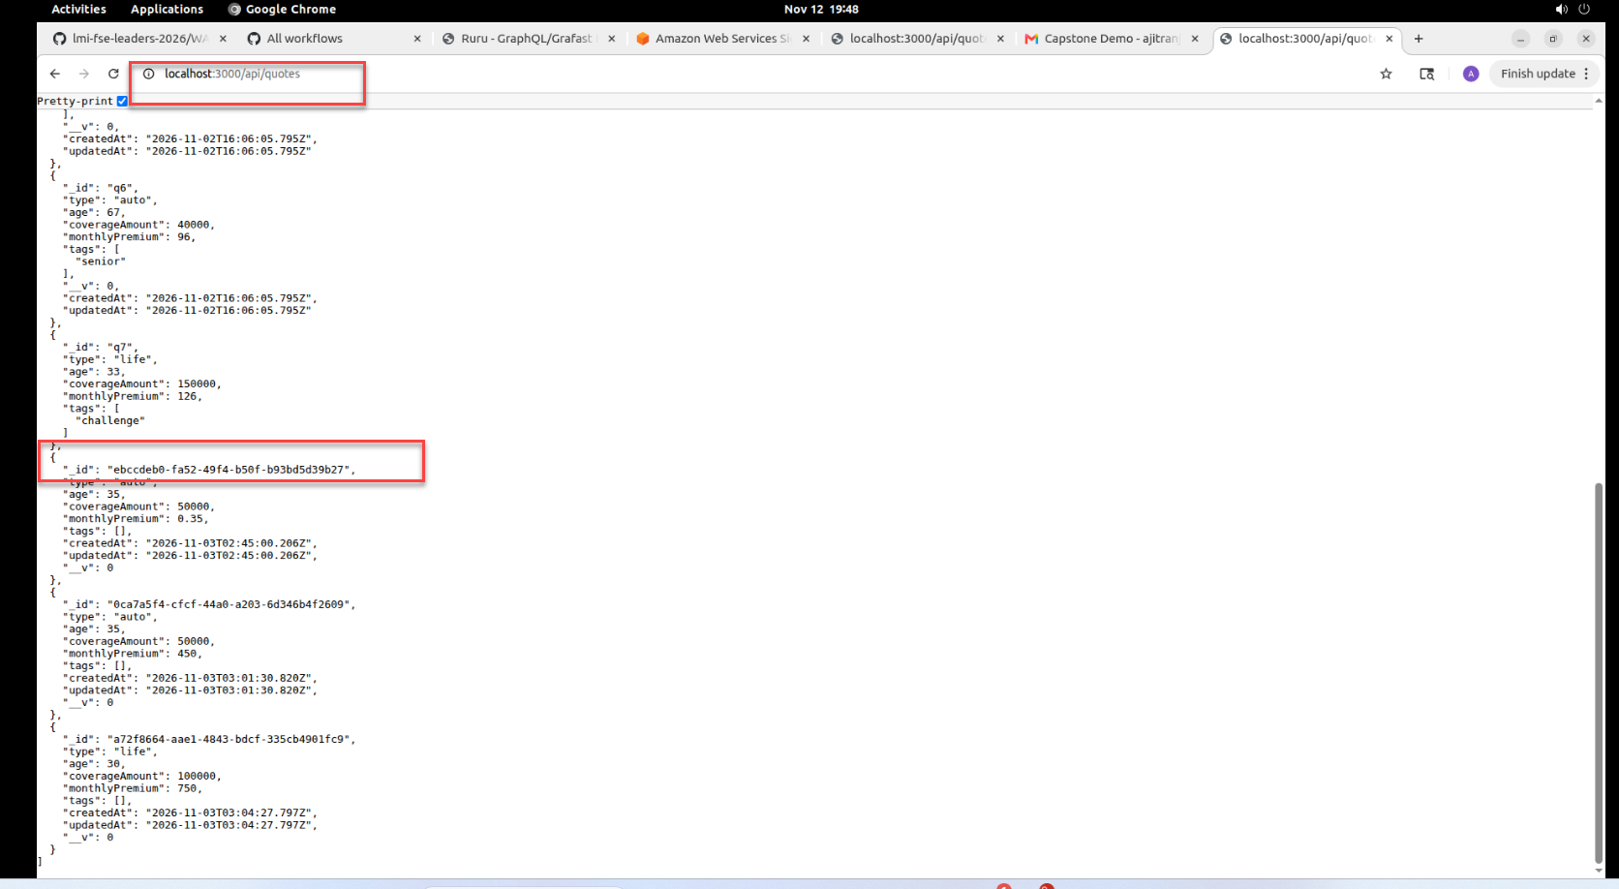
  - The container was validated using “docker PS” command. Its still running on Port 3000.
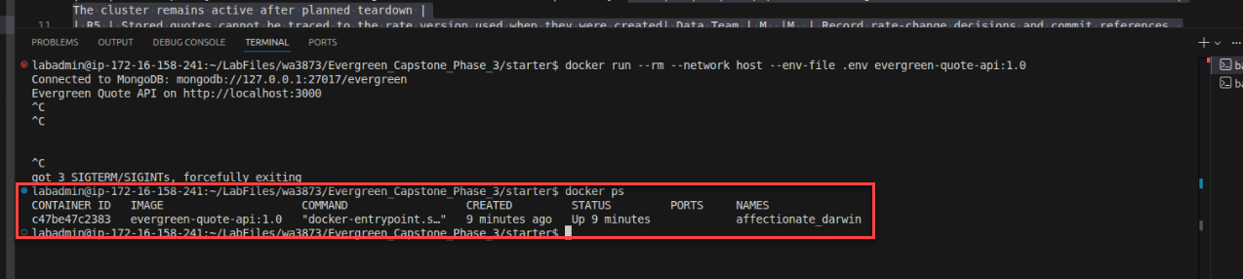

- Deploy to S3.
  - Website running in Localhost 8080.
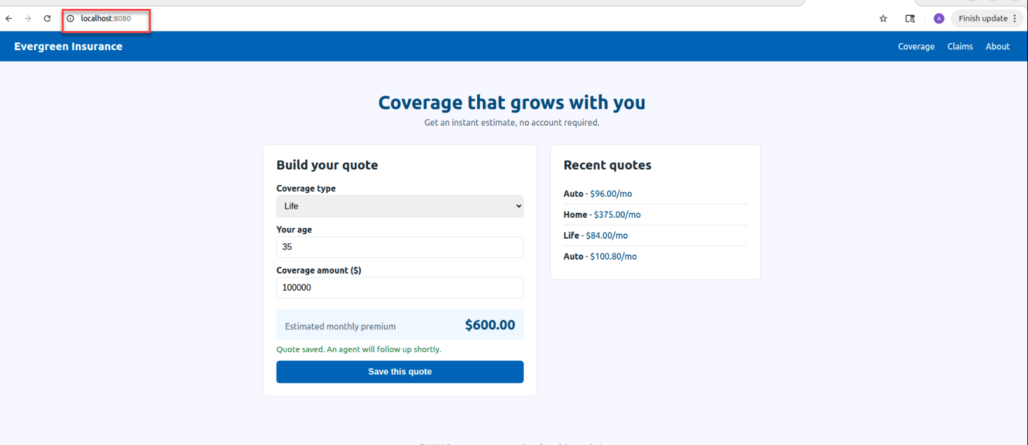
  - Bash command to deploy to S3 completed successfully.
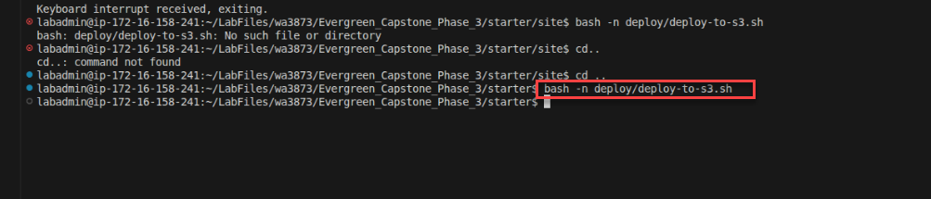
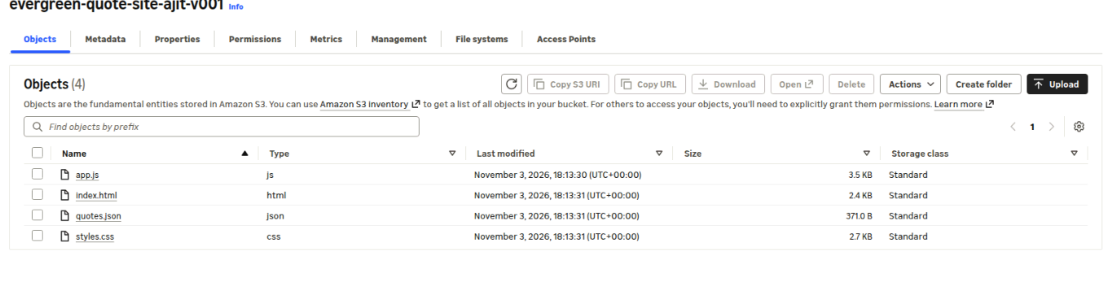
  - Website is displayed in AWS:
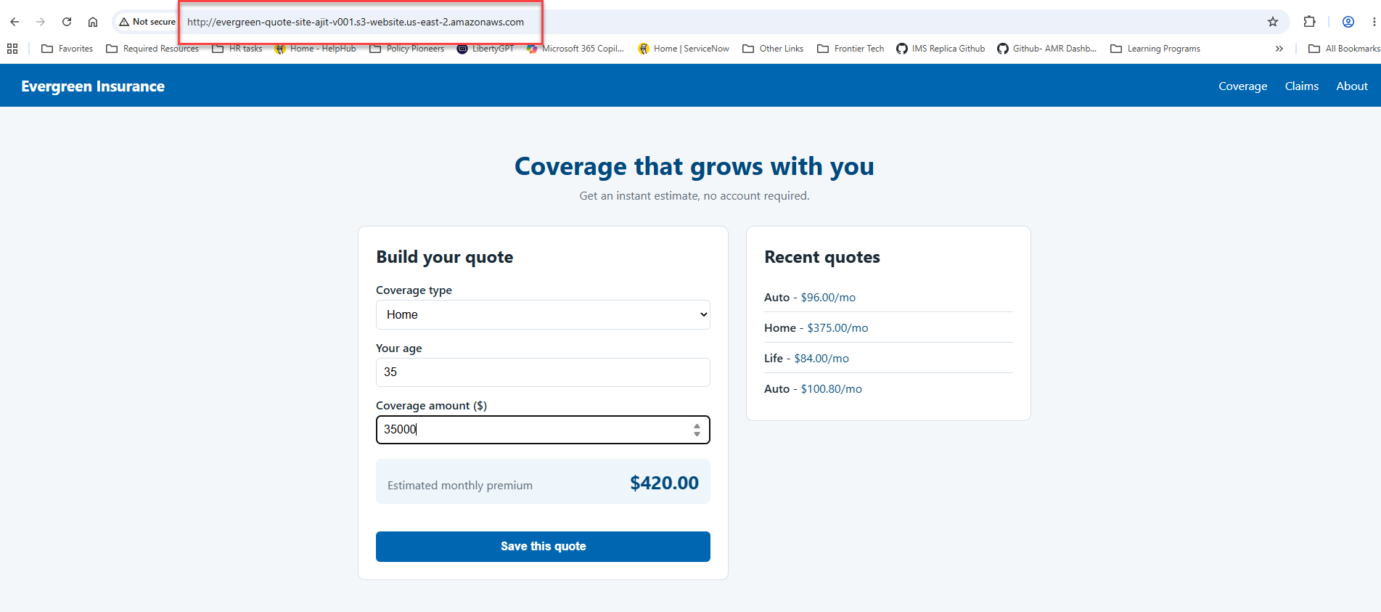

- Kubernetes :
  - Kubernetes running on 3 pods
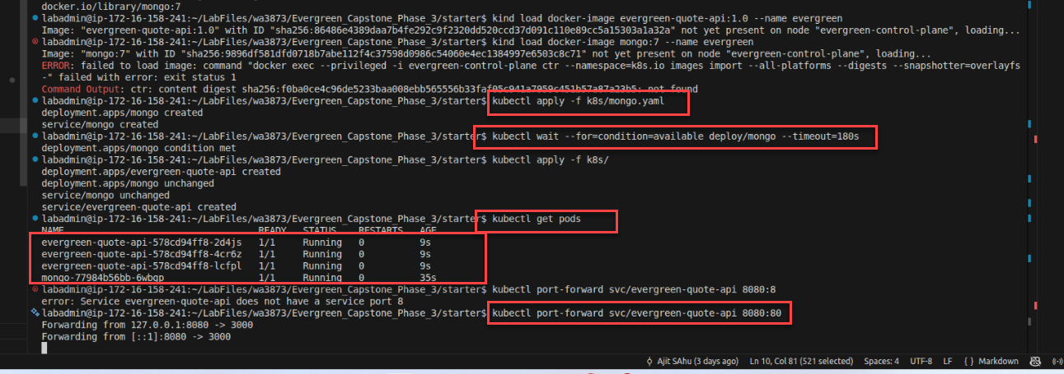
  - Running on Localhost 8080
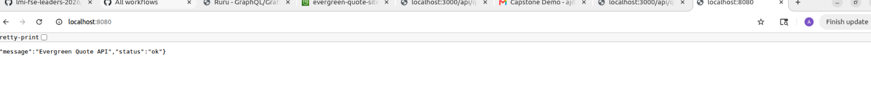
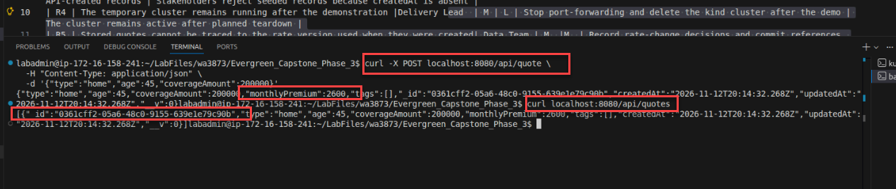
  - Kubernetes scaling – from 3 to 5 pods and then back to 3 works as expected.


